Monday
- ZEL + Wider Team
- SSWMB
  - Discussed waste concession – SSWMB informed that a waste concession to baseline & guarantee waste quantity and quality is not possible. SSWMB recommend discussing directly with collection companies to ‘cherry pick’ waste from specific collection routes / areas. Method of securing this waste will be to brief SSWMB staff to manually direct trucks at the landfill! All of this relies on verbal agreements, formal written agreements were dismissed as not necessary.
  - SSWMB made it clear that they would like to be shareholders in WtE project therefore, there is potential that we could use this as an incentive to agree a waste concession & waste quality testing for the long term future. Potential for SSWMB to contribute financially is to be explored.

Tuesday
- Landfill
  - Visited new site allocation – it became apparent that the original site had been earmarked as early as September / October for the landfill extension project and should never have been allocated to KREL to carry out the topographical survey. Reasoning given for late change of site did not mention this aspect, only that the original site had issues with proximity to the scavenger settlement and drainage. SSWMB were clearly keeping options open but were not completely honest with us.
  - New site has been used as a landfill – additional surveys are being executed to determine the extent of waste on the plot and therefore the additional work required to clear. WtE plant cannot be built on top of existing waste and so clearing the site is mandatory. (HSE and Bankability). In addition, it is likely that the ground is contaminated. A full assessment of contamination levels is required in order to baseline the ‘starting’ condition for the site. This important for the eventual recovery of the site after the term of the WtE plant.
- KREL Office

Wednesday
- EMC / URS
- Energy Ministry
  - Energy Senior Minister – shahid informed
- STDC
  - MOU discussed

Thursday
- ZEL / WG
- EMC – Deep Dive WCS
- Finance Deep Dive – Shabbir
- EPC Company Visit
- Bank Visit – Sietse
  - Meeting with HBL bank
  - Financing 70/30 max they think 60/40 will be more realistic
  - Inflation was 30%
  - A dollar loan of more than 50% will be difficult.
  - Conditional is the guarantee that FMO will join in this dollar loan or other development banks like ADB
  - Advice of HBL is to localize procurement as much as possible, that will be easier to finance locally
  - HBL confirmed:
  - Off taker KE electric has a higher bankability than STDC, despite the sovereign guarantee. The reason, KE will pay directly, the payment from the government are always delayed some times a half year.

Friday
- Dutch Embassy breakfast Meeting
- KREL office

Hi Jim could you check the following: (This is how I understood it sofar)

As we understand there is a pretty straight forward process from the award of the process towards FC.
It is 18 month plus a one time extension of 6 months. This process is put into a law. To deviate or to extend the process in time you will risk a law suit.
It is Shahid’s understanding that with the approval of the budget of 1,5 M euro, we settled for the process to reach the PPA.
- However, the achievable timing to reach PPA is now longer than expected and will overlap with the definition phase (Basic design and EPC tendering). Note: This means that investment to proceed within the allowed timescale (with extension) will be needed prior to PPA agreement / issue.
Shahid believes that the location and plot, off take tariff will be settled in a satisfactory manner and the waste will be secured.
- In our meetings with the stakeholders this was confirmed but any type of written commitment however was refused so far.
- Provisional land lease now agreed – will be converted to permanent at FC (mechanism to convert is not clear and will need to be detailed asap)

The FSR will get us to the tariff negotiation with KE electric, the initial tariff will be settled with STDC and they will push it to K-Electric and finally approved by NEPRA, hopefully SEPRA will be in place in June/July so not NEPRA will approve, but SEPRA.
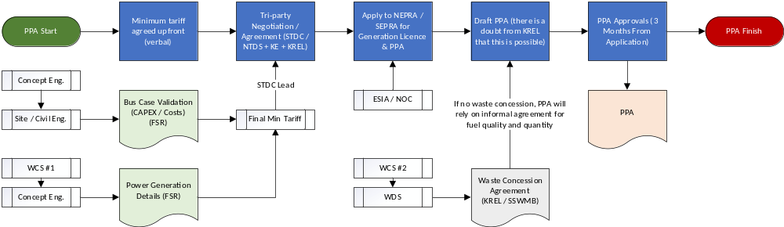
Land agreement – critical milestone - Land is crucial in any negotiation, because if no land than no project.

Shahid understands that the FSR and ESIA / NOC are not connected (completely independent streams of work).
- Our understanding is that conditional to the FSR is the EISA (SWEP regulations), but not the NOC.

Some miss understandings:

From Shahid side
- Shahid believes that we settled for the budget to reach PPA so no intermediate milestones are necessary.
- The light commitment on the waste and land is sufficient to reach FC. (mostly unconditional verbal agreements)
- Shahid has the idea that despite his sweat equity he should get paid for his work, his car and his supporting staff.
- Shahid could so far not pay Shabbir 5K per month, but hired an extra guy to support him!
- According Shahid KREL did pay for the conceptual design
- HW pushed for a monthly payment to KREL of 10K which is according to Shahid is not sufficient.
  - Requested that Shabir creates a cash flow to make clear the requirements of KREL (as would be made for a business plan to show expenditure)
- He keeps on asking for office and car.
- HW does not commit to its obligations
- PPA is of the shelf - it does not need any negotiation time – expected turnaround from application is three months (no formal process is cited)
- Tariff will be based on our pre feasibility quotation (225). Shahid expects there is no issue as it is based on the CAPEX of the project
  - Note: Original Pre-FSR and tariff was based on 2250 tpd @ 225M CAPEX, the 1500 TPD plant was quoted on 139M CAPEX! Need to fill this gap..

HW:
Shahid got sweat equity so need to pay him.
We often do not know what Shahid is dealing and committing to.
We believe there needs to be more securities in the project than the light commitments as in the land allocation, the waste commitment, the off take.
HW needs strong commitments in order to cover our financial commitment to the project.
Our in kind cost are not seen by KREL as financial commitment of HW.
- Need to reiterate sunk cost & hours applied

